LAB ASSIGNMENTS 1: Linux command On EC2 instance

Instruction:
1. create aws account
2. aws iam user
3. Create EC2 instance as demonstrated in the session
4. Practice linux command on Ubuntu machine

Practice all command from following categories as we discuss in the session

System and hardware informatation
User informatation and mgt
File and directory commands
file editing and navigation inside files
Piping and i/o redirection
Analysis and file manipulation commands
Wildcard chars
Package management
Services and Process mgt
file permission

1.create aws account
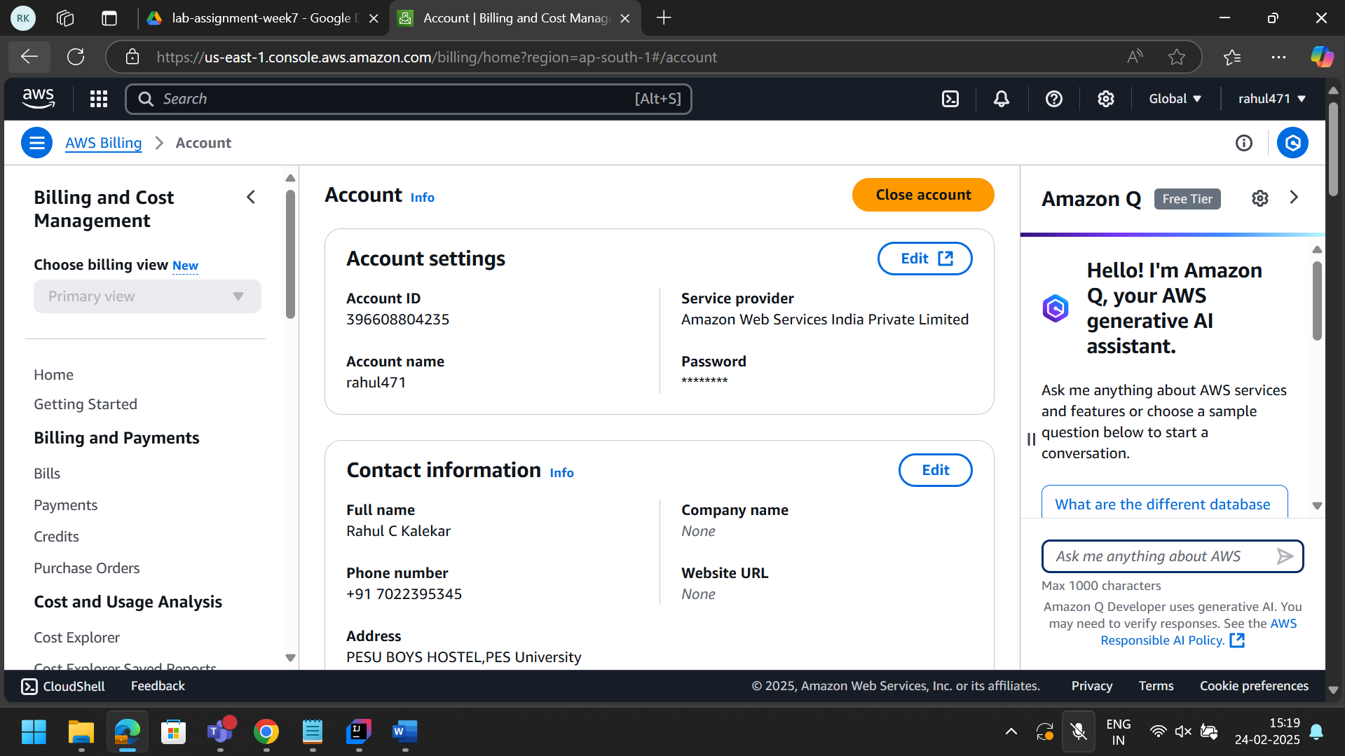

2. aws iam user

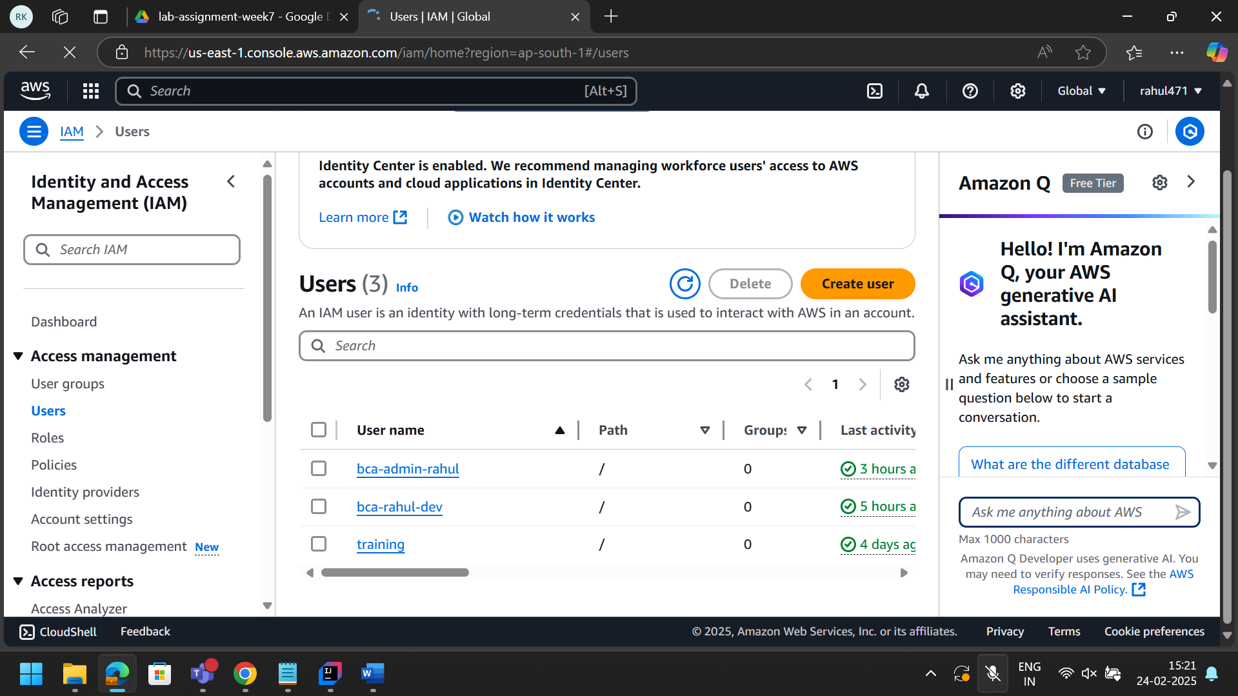

3. Create EC2 instance as demonstrated in the session
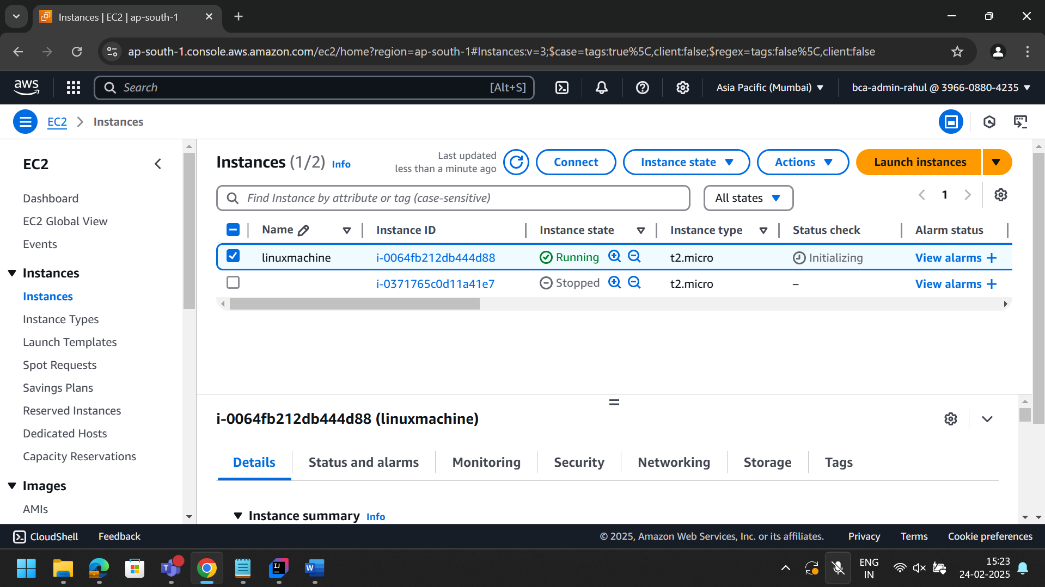

4. Practice linux command on Ubuntu machine

